AMC501-F
Packing controller instruction manual

©2018 Shenzhen Accurate Measurement and processing
Technology Co ltd, copyright ownership.

Without permission from Shenzhen Accurate Measurement and processing Technology Co ltd, No unit or individual shall reproduce, disseminate, transcribe or translate into another language in any form or by any means.

As our products have been continuously improved and updated, we reserve the right to revise this manual without further notice. To do this, visit the company's website frequently to get timely information.
Company web site：http://www.szamp.com.cn/

This product carries out the standard:
GB/T 7724-2008< Electronic weighing meter > national standard
JJF1624-2017 Plan of Study for < Digital weighing display (weighing indicator)> form
JJG649-2016 digital weighing indicator（weighing Indicator）Verification regulation
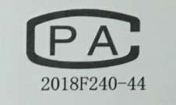

directory
1. Basic Information 1
1.1. Features and Specifications 1
1.2. Connection Port 3
1.3. Sensor wiring method 3
1.4. Switch connection and definition 4
1.4.1. Switch wiring diagram 4
1.4.2. Interface definition 5
1.5. Mounting Dimension 6
2. Main Interface 7
3. Parameter settings 9
3.1. Weight calibration 10
3.1.1. Weight calibration 10
3.2. Basic Wt Para. 12
3.3. Control Parameters 14
3.3.1. Clamp 14
3.3.2. Feed process 15
3.3.3. Fixed process 17
3.3.4. Push and unloading 20
3.3.5. Level set 24
3.4. Recipe parameters 26
3.4.1. Recipe number 26
3.4.2. Target value 27
3.5. IO 28
3.5.1. IN Def. 28
3.5.2. Out Def. 30
3.5.3. IO Test 33
3.6. Batch and accumulation 35
3.6.1. Batch and accumulation 35
3.6.2. Historical data 36
3.7. Communication parameters 37
3.7.1. RS232 set 37
3.7.2. RS485 set 38
3.8. modify -Admin-pass 39
3.9. System 40
3.9.1. Para. reset 40
3.9.2. Date/Time 40
3.9.3. register 41
3.9.4. backup recover 41
3.9.5. Import and export 42
3.10. Logic program 44
3.10.1. Logical output sequence diagram 47
3.10.2. Example 49
4. Process instruction 51
4.1. Valve Scale packaging process 51

Basic Information

Features and Specifications
AMC501-F is based on the Chinese touch screen single channel bucket valve port quantitative packaging controller instrument, support blowing, push bag, unloading control. AMC501-F adopts high color TFT touch screen, which supports Chinese input and Chinese display. It has a beautiful graphical interface, reasonable functional classification and layout. All these excellent features make AMC501-F very easy to use.
AMC501-F packaging controller has the following basic features：
●Terminal TFT high color touch screen, input and display in Chinese and English
●Perfect process control function, blowing, push bag, unloading control.
●The accumulative data supports USB export.
●Up to 100,000 packaging historical data storage features, support USB export.
●Setup data support for native backup and USB export
●Weighing channel: single channel
●Working voltage：DC24V
●Sensor：DC5V/4-wire and 6-wire system compatible
●Switch quantity：7 input /12 output
●Installation method：cubicle outfit（Panel mounting）
●Volume：203×149×50（Length * width * height，mm）

The detailed technical specifications are as follows：
Transducer Excitation | DC5V±10%/120mA Drive current/can receive eight Ω 350 specifications of the sensor
Adaptive Sensor Sensitivity | 2mV/V or 3mV/V
Input Signal Range | 0～15mV
Minimum Input Sensitivity | 0.5uV/d
Nonlinearity | 0.02%FS（3mV/V hour）
Zero Drift | ＜0.5μV/℃
Gain Drifting | ＜10PPM/℃
AD Rate | 960 Times/Seconds
Maximum Accuracy of Display | 1/100000
Product Accuracy Grade
Working Voltage | DC24V(18V~30V compatibility)
Product Power Consumption | ＜5W
Operating Temperature Range | -10℃~45℃
Storage Temperature | -20℃~60℃
Humidity | Within 90%RH（No Condensation）

Connection Port
The connection port is shown :

Sensor wiring method

Switch connection and definition

Switch wiring diagram
Examples of the wiring diagram of input switching volume are shown in the figure below (taking IN1, IN2 and IN5 as examples) :
The external circuit drives the input switch volume to meet two key points, as follows:
1. The external circuit shall be co-located with controller；
2. When the external circuit inputs low power, it means that the input is valid; otherwise, it means that the input is invalid.
Examples of wiring diagrams of output switches are shown in the following figure (OUT6, OUT7, OUT8, OUT12 as examples) :
The external circuit driven by output switching quantity should meet two key points:
1. The external circuit shall be co-located with controller；
2.When switching output is effective it’s low powe.
Note: The maximum driving capacity of each switch outlet is 500mA. Please pay attention to the power of the load when connecting the load. When exceeding the driving capacity of the output outlet, it may cause damage to the switch outlet.

Interface definition
interface | instructions | interface | instructions
24V+ | DC24V+ | 24V- | DC24V-
switch volume input
IN1 | I1.start（pil） | IN2 | I4.stop
IN3 | I5. zeroing | IN4 | I6 Clear alarm
IN5 | I3 slowly stop | IN7 | I9. clip/release bag
IN7 | I0.No definition
switch volume output
OUT1 | Q1.running | OUT2 | Q2.stop
OUT3 | Q3.fast | OUT4 | Q4.med
OUT5 | Q5.slow | OUT6 | Q6. fixed value
OUT7 | Q7. ove/und | OUT8 | Q8. warning
OUT9 | Q9.clip Bag | OUT10 | Q10. push bag
OUT11 | Q17. release bag | OUT12 | Q16.blowing materials
Sensor interface
EX+ | Load Cell Excitation+ | EX- | Load Cell Excitation-
SN+ | Load Cell Sense+ | SN- | Load Cell Sense-
SI+ | Load Cell Signal+ | SI- | Load Cell Signal-
SHG | Load Cell Shielded Wire

Mounting Dimension
bottom view of the product，data unit：mm
Recommended installation hole size：192mm×138mm

Main Interface
After the power start is completed, the main interface is entered, as shown in the figure below：
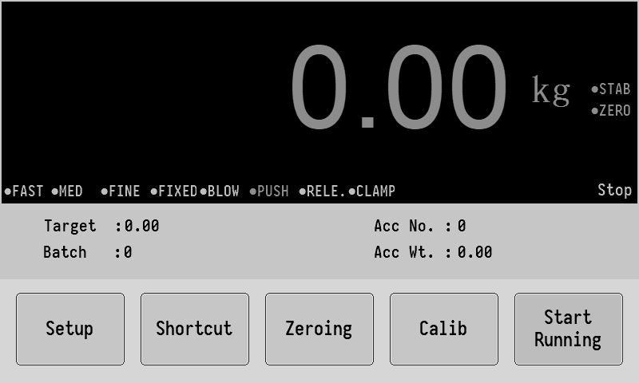
The top column shows the current weight value, as well as status indicators such as weight ,stability, zero, etc and the detailed running steps of the controller.The middle two columns show the following:
【target】That is the target packaging weight of the current Recipe used.
【batch】The target requires the number of packages to be packed.
【Acc No.】Total number of total times packages completed.
【Acc Wt】Total completed packages weight.
Click the display location of accumulated data to clear the accumulated data.

At the bottom of the column is the function key, which can be used for some parameter setting and operation.
start runningThe gray color indicates the stop state，click on thestart running,If no error is reported, the system will start the packaging workflow.
calib button can enter the calibration interface.
zeroing Perform zero clearing for the current gross weight. When the button is gray, it means it is not available. For example, when running, it is gray.
shortcut Click to enter the setting interface of formula parameters and related parameters of blowing and pushing bag unloading.

Parameter settings
Click setup on the main interface enter the parameter setting interface,as shown in the following figure:
(Default administrator password:000000)
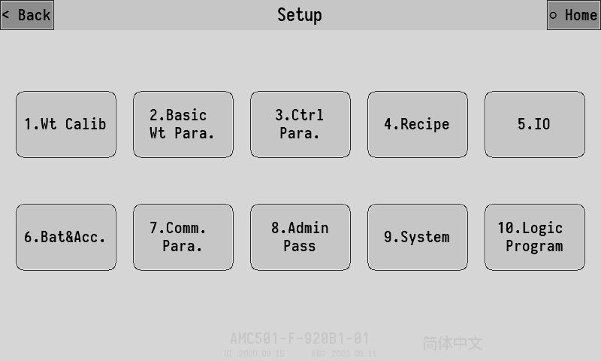
This screen lists all of the controller parameter Settings options.
The model and software date of the controller are displayed at the bottom of the screen. Click English and Chineseon the bottom right corner can toggle between Chinese/English displays.
The following is a detailed description of each major item in system maintenance.

Weight calibration
Before using the new equipment, it is necessary to calibrate the weight and set the system parameters such as unit, decimal point, minimum division and maximum range.

Weight calibration
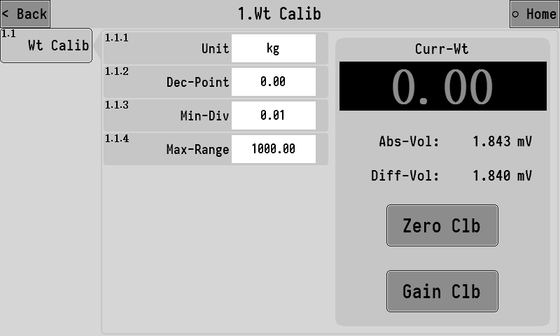
The absolute voltage shown in the right column is the current voltage value of the sensor. The normal range of this value is 0~15mV，if the value exceeds this range, the signal of the weight sensor is abnormal. Check whether the sensor is damaged or whether the line connection is normal and reliable.
Relative voltage,it is the difference of the current absolute voltage minus the voltage value at the zero point calibration, which is equivalent to the voltage value generated by the gain weight.
The calibration process can be completed only by zero calibration and gain calibration, the operation is as follows:
- Empty scale， click zero calibration after the signal stabilizes (absolute voltage does not beat)，success will be marked zero success prompt.
- Put weights or objects of known weight on the scale, click Gain calibration after the signal stabilizes (absolute voltage does not beat)，At this point, out of the input box, input the exact weight of the placed object is Ok, when successful, the calibration gain will be indicated.
After the above two steps are completed, the weight calibration process will be completed, and the controller will display the accurate weight value on the scale.

Basic Wt Para.
Click 2.Basic wt para. on the system maintenance interface to enter the setting interface of basic weighing parameters, which is as follows:
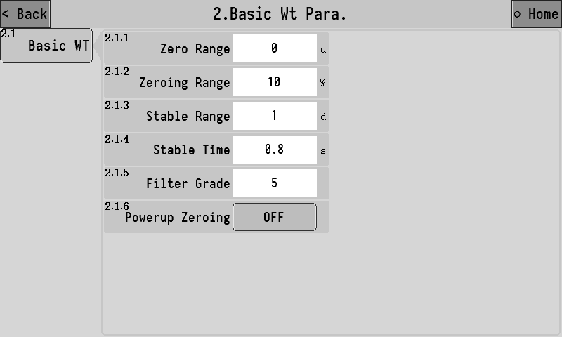
Parameter description list:
2.1.1 | zero range | It only works in the stop state, and the weight value is stable within the positive and negative range of the set value ×d (minimum indexing value) to automatically clear zero.
2.1.2 | zeroing range | When performing the zero clearing operation, weight must be less than or equal to "maximum range × zeroing range" to allow zeroing.
2.1.3 | Stable range | These two parameters work together to determine whether the weight is stable.  Take all the weight values within the "stability judgment time", and the difference between the maximum value and the minimum value is less than or equal to the "stability judgment range", then the weight value is considered stable at this time.
2.1.4 | Stable time
2.1.5 | Filter grade | Software digital filtering intensity level, according to the actual debugging effect of the equipment to set the appropriate filtering level parameters.  0：The filtering effect is the weakest, the weight response is fast, and the anti-vibration effect is poor;  9：The filtering effect is the strongest, the weight response is slow and the anti-vibration effect is good.
2.1.6 | powerup zeroing | After opening,the controller will automatically reset every time the machine is turned on

Control Parameters
Click 3. ctrlpara. on the system maintenance interface, enter the interface of setting control parameters of valve port scale. The parameters can be divided into several categories according to functions and control flow.

Clamp
The relevant function parameters of the clamp can be set.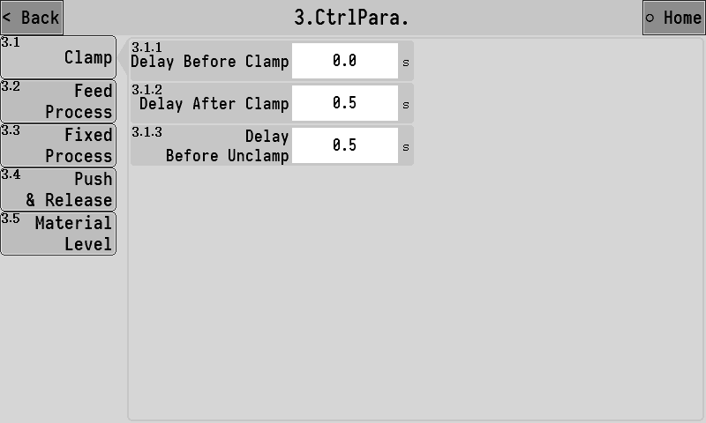

3.1.1 | Delay before clamp | After the "clamp" signal is input, the clamp will be output after this time delay.
3.1.2 | Delay after clamp | After the output of " clamp" signal is effective, the bag-clamping action is considered to be completed after the delay time, and the following process can be continued.
3.1.3 | Delay before unclamp | After the judgment condition of loose bag is reached during operation, the loose bag will start to be loosened after the delay time.

Feed process
Set the parameters of each function in the feeding process.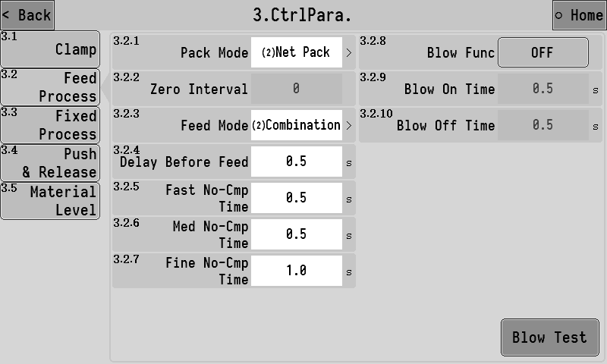

3.2.1 | Pack mode | 1.[ Gross weight packing]：Do not remove the leather before feeding, and start feeding directly.  2.[ net pack]：Before feeding, make sure to remove the skin and start feeding.
3.2.2 | Zero interval | Under the gross weight packing mode, the zeroing operation is automatically carried out after several times of packing.
3.2.3 | Feeding mode | 1.[ Independent feeding]：  Fast speed：Fast signal output is valid.  Med speed：Med signal output is valid.  Slow speed：Slow signal output is valid.  2.[ combi-feed]：  Fast speed：The output of fast, moderate and slow signal is effective  Med speed：Moderate and slow signal output is effective  Slow speed： Slow signal output effective.
3.2.4 | Delay before feed | The delay time before the start of feeding is completed.
3.2.5 | Fast no-cmp time | The vibration elimination time at the beginning of the fast feeding, during which the fast feeding signal is always valid and not affected by the weight. After the time, it will be judged whether the weight reaches the amount before the fast feeding and thus ends the fast feeding.
3.2.6 | Med no-cmp time | The vibration elimination time at the beginning of the moderate feeding, during which the moderate feeding signal is always valid and not affected by the weight. It is not until the end of the time that the weight reaches the lead amount of the moderate feeding to end the moderate feeding.
3.2.7 | Fine no-cmp time | The vibration elimination time at the beginning of the slow feeding, during which the slow throw feeding is always effective and does not be affected by the weight.
3.2.8 | Blow func | Main switch of blowing function  1.[opened]：The blowing signal of the output interval during feeding  2.[closed]：。
3.2.9 | Blow on time | The effective time of the blowing signal output during the blowing process.
3.2.10 | Blow off time | The invalid time of the blowing signal output during the blowing process.

Fixed process
Set the related functional parameters of the process of setting the values after the feeding is completed.

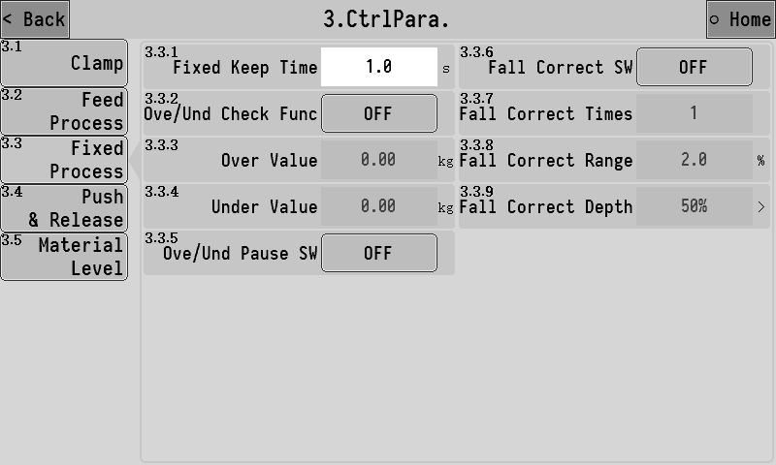

3.3.1 | Fixed keep time | At the end of feeding, the functions such as result accumulation, error detection and error correction will be performed after waiting for this time.
Ove/und check func
3.3.2 | Ove/und check func | Master switch for Ove/und check func  1.[opened]：The feeding results will be ove/und test-time tested after each feeding.  2.[closed]:No fall and over/under detection is performed.  fall and over/under is the general term for overbalance or underbalance. In the packaging process, if the packaging result is higher than a certain range of the target value, it is considered to be out of tolerance, while if it is lower than a certain range, it is considered to be undertolerance, which is set according to the production demand.
3.3.3 | Over value | In the Ove/und check func , if the weight result is > target value + excess value, it is judged to be out of tolerance；
3.3.4 | Under value | In the Ove/und check func , if the weight value < target value - under value, it will be judged as under difference.
3.3.5 | Ove/und pause SW | When both the overbalance alarm switch and the overbalance suspension switch are on, if there is an over/under , the controller will alarm and wait for the user to deal with it, at this point, continue operation after "clear alarm", or give a "stop" signal to return to the stop state for processing.
Fall correct function
In some cases, it may be necessary to use the drop correction function to improve the packaging accuracy. The drop correction function is to constantly revise the small drop drop value during the operation. The principle is as follows:
1. Target difference = the weight result -- target value
2. Target difference average = (target difference 1 + target difference 2 +... + target drop correction times)/drop correction times;
3. New small throw head = the last small throw head + the average of the target difference x the drop correction range;
3.3.6 | Fall correct SW | Master switch for fall correct function.  1.[opened]：The fine feed is calculated and corrected automatically after feeding.Fine feed.  2.[closed]：No drop correction.
3.3.7 | Fall correct times | The average of the drop value of the set times is taken as the basis for the correction of the drop correct.
3.3.8 | Fall correct range | Percentage of the target value. When this drop exceeds the set range, this drop will not be included in the arithmetic mean range.
3.3.9 | Fall correct depth | There are 25 percent, 50 percent, 75 percent, and 100 percent optional for each drop correct depth.

Push and unloading
Set the parameters related to the control function of pushing and unloading bags.
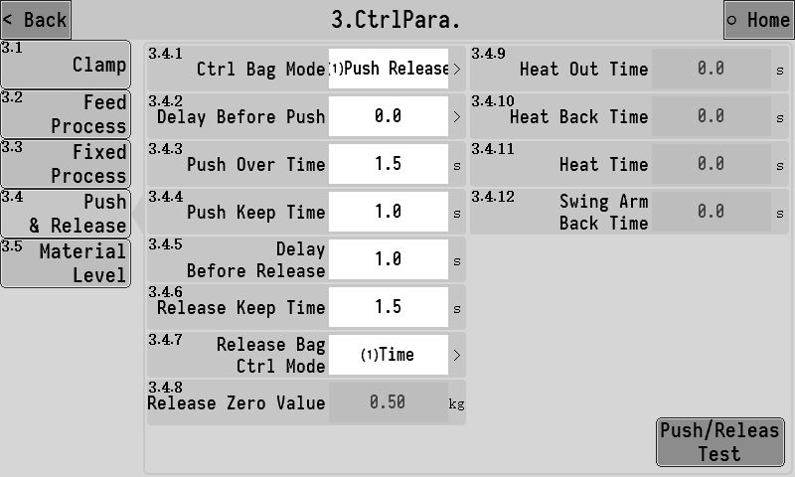

3.4.1 | Ctrl bag mode | 1.[ Push and unloading]：After loose bag perform pushing and unloading.  2.[ Push,heat and unloading]：After loose the bag, push, heat and unload.
3.4.2 | Delay before push | The delay time before the bag pushing action begins
3.4.3 | Push over time | “After the signal output of "push bag" is effective, if the input signal of "push bag in place" is detected within this timeout period, the push bag action is considered to be completed.  If the input signal of "push bag in place" is invalid all the time, the push bag action is considered to be completed after the timeout.  After the push action is completed, the unload function begins.
3.4.4 | Push keep time | When the output signal of " unload" is invalid, start the holding time of pushing bag. After this time, close the output signal of " unload"
3.4.5 | Delay before release | The delay time before the bag unloading function begins,this delay time to output the " unload " signal.
3.4.6 | Release keep time | The holding time of the " unload " output signal.
3.4.7 | Release bag ctrl mode | 1.[time]：The effective time of "unload " signal output is controlled by [3.4.6 Unload keep time].  2.[Unload zero value]：When the output of "bag unloading" signal is effective, when the weight is lower than [zero zone value of unload], start the unload holding time, and close the output signal of " unload" after the holding time.
3.4.8 | Release zero value | See [3.4.7 unload control Mode] for details.
3.4.9 | Heat out time | Control the heat sealing action.  1. Output "push bag" signal and wait for "push bag in place"；  2. When "push bag in place" or "push bag timeout" is detected, the push bag is considered to be in place.  3. The output "swing arm output" signal controls the swing arm cylinder shrinkage. When "swing arm shrinkage in position" or "swing arm shrinkage time" is detected, the swing arm shrinkage is considered to be completed.  4. The output "heat seal output" signal controls the extension of the heat seal cylinder. When "heat seal extension in place" or "heat seal extension time" is detected, it is considered that the heat seal extension is in place.  5. Turn off the "heat sealing output" signal and let the heat sealing cylinder shrink back. When "heat sealing shrinkage in place" or "heat sealing shrinkage time" is detected, the heat sealing shrinkage is considered to be in place.  6. Close the "push " signal and wait for "heating time";  7. Output "heat seal output" signal controls the extension of the heat seal cylinder. When "heat seal extension in place" or "heat seal extension time" is detected, it is considered that the heat seal extension is in place.  8. Output the " unload" signal, and close the "heat sealing output" signal to let the heat sealing cylinder shrink back, waiting for the completion of bag unloading and the heat sealing shrinkage in place;  9. Turn off the "swing arm output" signal;
3.4.10 | Heat back time
3.4.11 | Heat time
3.4.12 | Swing arm back time

Level set
Set the level signal input and feed related functional parameters.
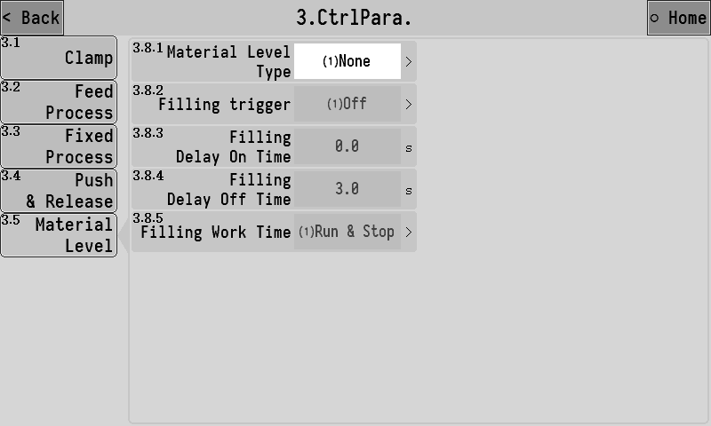
3.5.1 | Material level type | 1. [ No level gauge]：No level gauge.  2.[Single down feed level]：There is a feed level (feed level)  3.[ feeding level and feeding level]：There are 2 levels (feeding level and feeding level).  4.[Single up feed level]：There is a feed level (feed level)  Note: If the mode containing the blanking level is selected, feeding will not start if the blanking level signal input is invalid.
3.5.2 | Filling trigger | 1.[close]：Turn off filling trigger finction.  2.[ Blanking level trigger.]：Trigger feeding function when blanking level input is invalid.  3.[ Feeding level trigger]：Trigger feeding function when feeding level input is invalid.  Note: When the feed level mode is set to [up and down feed level], the feed work will continue until the feed level signal is effective.
3.5.3 | Filling delay on time | After the feeding function is triggered, the feeding signal will be output after the delay of this time.
3.5.4 | Filling delay off time | After the end of feeding, the feed signal output should be closed after the delay of this time.
3.5.5 | Filling work time | 1.[ Feed both when running and when stopping]。  2.[ Run only feed]。

Recipe parameters
The controller has 20 sets of formula parameters for setting. Users can set the commonly used formula parameters in advance and switch to the corresponding formula when using.

Recipe number
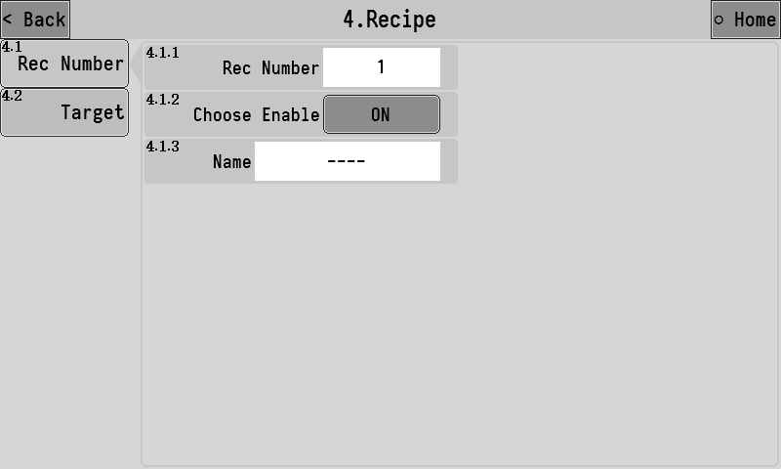
4.1.1 | Rec number | Set the currently used recipe number.
4.1.2 | Choose enable | After it is opened, when the recipe number is selected by clicking the recipe number position on the main interface, the recipe will be in an optional state.
4.1.3 | Name | The name of the formula can be entered for easy memory. After setting, the corresponding recipe name will be displayed in the recipe number position on the main interface.

Target value
This interface sets the target value of the recipe number and other formula parameters.
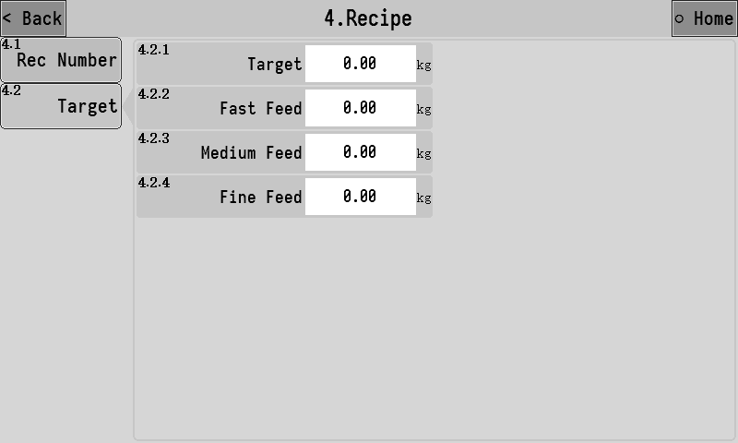
4.2.1 | Targrt | Set the target weight for the package.
4.2.2 | Fast feed | When the weight value is greater than the target value – fast feed in feeding, turn off the fast feed
4.2.3 | Med feed | When the weight value is greater than the target value –med feed in feeding, turn off the med feed
4.2.4 | Fine feed | When the weight value is greater than the target value –fine feed in feeding, turn off the fine feed

IO
The functions corresponding to the input and output of switching variables can be defined, and the IO test function can be used to test whether the circuit of external switching variables is normal.

IN Def.
Define the corresponding functions of switch input ports IN1~IN7. Click the input port of the switch to be set, and select the function to be defined in the popup box.
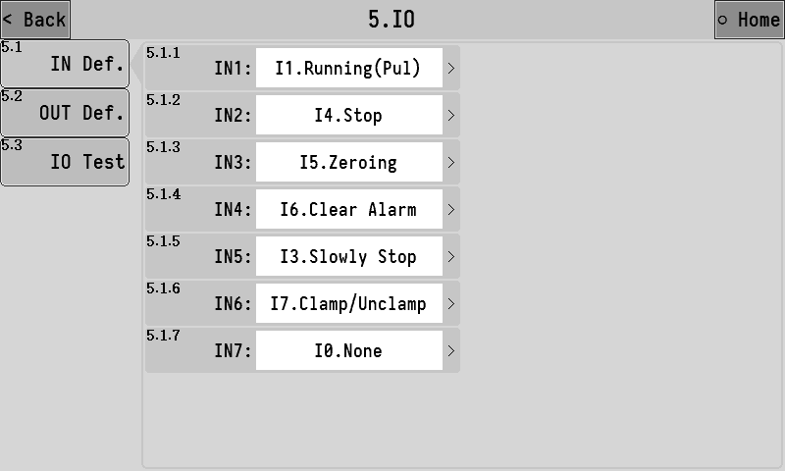
The list of functions available for switching input is as follows:
Function number | Function name | Describe
I0 | None | No functional definition.
I1 | running(pul) | Start running.
I2 | running(lvl)） | Effective start, invalid stop.
I3 | slowly stop | Enter the slow stop process, that is, after the completion of this packaging automatically stop running.
I4 | stop | Stop running.
I5 | zeroing | Perform a zero clearing operation.
I6 | clear alarm | Clear alarm status.
I7 | Clamp/unclamp | Clip/release operation input signal.
I8 | Clamp ok | Effective that the clamping mechanism action in place.
I9 | upper level | Upper feeding level detects input signal.  When effective, it is considered that the material has reached the upper loading level.
I10 | lower level | Lower blanking level detects input signal.  When effective, it is considered that the material has reached lower level.  When invalid, it is considered that the material is lower than the cutting and is in the state of material shortage.
I11 | safely on-off | In the stop state, when the input is valid, enter the running state and clamp; When this input is valid in the running state, simply stop and loosen bag.
I12 | Push ok | Effective that the bag pushing mechanism action in place.
I13 | Plugging | The signal shall be detected before bag unloading, and only after the signal is invalid can bag unloading begin.
I14 | Air pressure | Used to connect voltage detection equipment. When effective, prompt alarm: "low air pressure, pause"
I15 | Bag fault | Automatic bag loading machine fault, effective after the instrument start a push bag and unloading bag.
I16 | Swing Arm ok | Heat seal associated action signal.
I17 | Hot seal out ok | Heat seal associated action signal.
I18 | Hot seal back ok | Heat seal associated action signal.

Out Def.
Define the corresponding functions of switch output OUT1~OUT12. Click the switch output outlet to be set, and select the function to be defined in the pop-up option box.
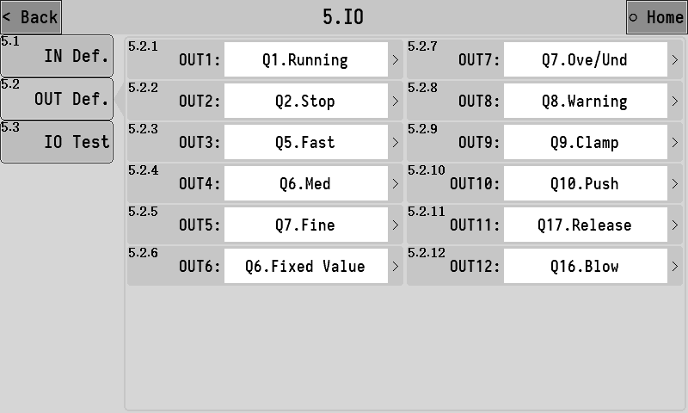
The list of functions available for switching output is as follows:
Function number | Function name | Describe
Q0 | None | No functional definition.
Q1 | running | The output is valid while running.
Q2 | stop | The output is valid when the state is stopped.
Q3 | fast | Fast feeding speed control signal.
Q4 | med | Med feeding speed control signal.
Q5 | fine | Slow feeding speed control signal.
Q6 | fixed value | When the feeding is completed, the output is valid, indicating that the feeding has been completed at present, and the duration can be set [3.6.1 Fixed retention time].
Q7 | ove/und | The ove/und function is on. When the ove/und alarm occurs in the feeding result, the output is effective.
Q8 | warning | The output is valid when the controller has alarm.
Q9 | clip bag | Bag clamping mechanism control signal, when effective clamping, when invalid bag loose.
Q10 | push | Push bag mechanism control signal.
Q11 | filling | Feed control output signal.  When the signal is valid, start the feeding device to feed the material into the storage hopper.
Q12 | batch complete | The signal output is valid after the batch is completed.
Q13 | starving | Lack of material state output signal.  When the signal input of "lower level" is invalid, it is in the state of material shortage.
Q14 | sever material | The output is valid when feeding.
Q15 | feed | The output is valid when feeding.
Q16 | blow | Blowing function output signal.
Q17 | release | Control signal of bag unloading mechanism.
Q18 | Allow clamp | Automatic bag loading function with signal.
Q19 | Clamp complete | Automatic bag loading function with signal.
Q20 | Swing arm | Heat seal function control signal.
Q21 | Heat seal
Q22 | Logic 1 | Logic programming 1 function output signal.
Q23 | Logic 2 | Logic programming 2 function output signal.
Q24 | Logic 3 | Logic programming 3 function output signal.
Q25 | Logic 4 | Logic programming 4 function output signal.
Q26 | Logic 5 | Logic programming 5 function output signal.
Q27 | Logic 6 | Logic programming 6 function output signal.

IO Test
Switch volume test is used to test whether the input switch volume and output switch volume work normally.The interface, as shown below:
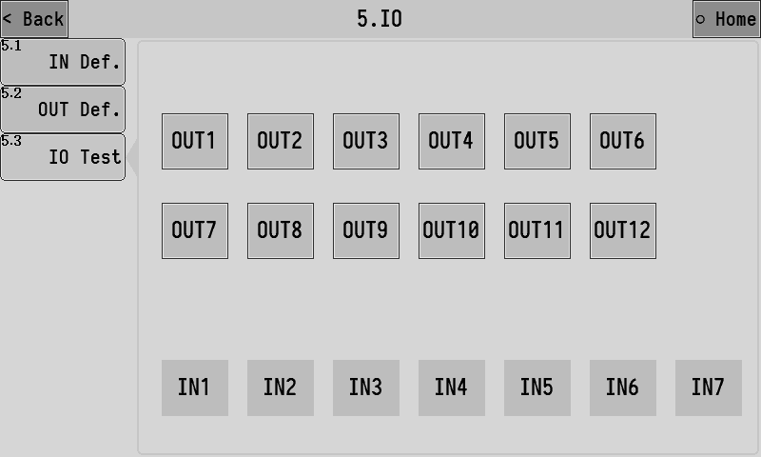
Switching output test:
The OUT1~OUT12 buttons are used to test the output function of the switch volume. Grey indicates that the output of switching quantity is invalid, while green indicates that the output of switching quantity is valid.
For example:
The OUT3 output outlet is connected with the relay. To test whether the output of OUT3 is normal, click the OUT3 button to switch the output state to valid, If the line is normal, it can be observed that the relay connected on OUT3 pulls in. Click OUT3 button again to switch the output state to invalid, If the line is normal, it can be observed that the relay connected on OUT3 is disconnected.
IO Input Definition：
IN1~IN7 is used to test the input function of switching volume. Grey indicates that the switching input is invalid, while green indicates that the switching input is valid.
For example:
A button switch is connected to the IN1 input port. To test whether the button switch is normal, you can manually press the connected button. If the line is normal, you can observe that the IN1 indicator light turns green. After releasing the button, if the line is normal, the IN1 indicator will be observed to turn gray.

Batch and accumulation
View the accumulated and historical data of the controller.

Batch and accumulation
View the cumulative value of the control and set the number of runs. The interface is shown as follows:
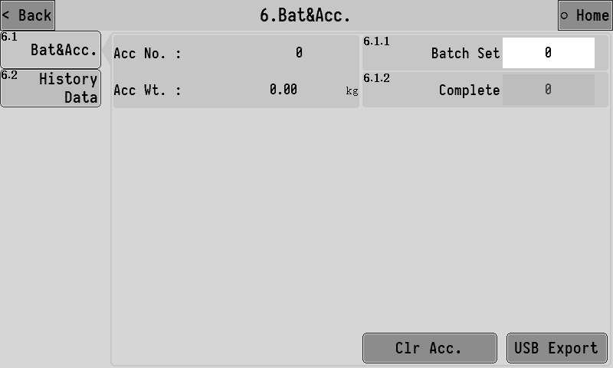
6.1.1 | batch set | set the number of packages. When the number of runs reaches the number of batches set, the packaging process will be stopped and the alarm will be alerted. Turn off the function when set to 0.
6.1.2 | Complete | If batch number is set, this item displays the number of batches currently completed.
When the controller is inserted into the USB flash disk, the accumulative data file can be exported to the USB flash disk in CSV format.

Historical data
View the packaging history, including items such as the cumulative number of packages, dates, results, recipe parameter Settings, and packaging time.
The controller can store up to 100,000 pieces of historical data. When the storage space is full, the storage will be restarted from sequence number 1 and overwrite old data.
When the controller is inserted into the USB flash disk, the historical data file can be exported to the USB flash disk in CSV format.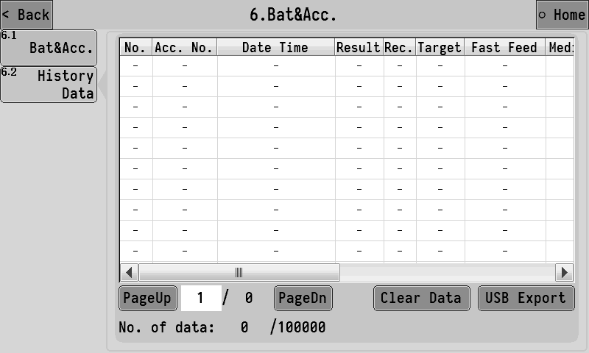

Communication parameters
The controller can be equipped with two completely independent serial communication interfaces, RS232 and RS485, and the communication parameters of the two serial ports can be set respectively.

RS232 set
Set RS232 communication serial port relevant parameters: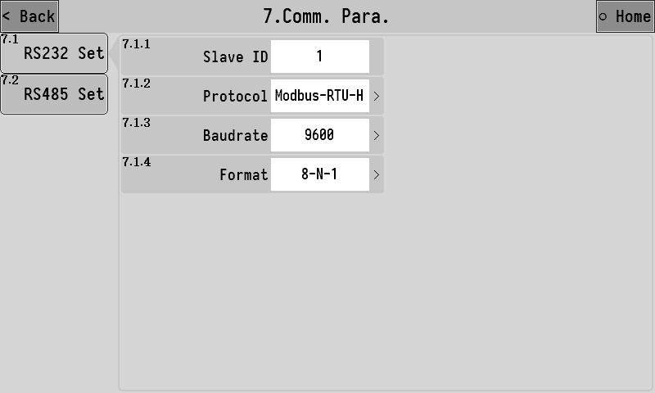
7.1.1 | Slave ID | Set the device's communication address (slave station number).
7.1.2 | Protocol | 1.[Modbus-RTU-H]：Modbus-RTU Communication protocol (two-word data with high characters before).  2.[Modbus-RTU-L]：Modbus-RTU Communication protocol (double word data with low word before).
7.1.3 | Baudrate | Set the baudrate for serial communication
7.1.4 | Format | 1.[7-E-1]:7 Data bit, parity, 1 stop bit  2.[7-O-1]:7 Data bit, odd check, 1 stop bit  3.[8-N-1]:8 Data bit, no check, 1 stop bit  4.[8-E-1]:8 Data bit, parity, 1 stop bit  5.[8-O-1]:8 Data bit, odd check, 1 stop bit

RS485 set
Setting method refer to 3.7.1.RS232 setting.

modify -Admin-pass
When leaving factory, the administrator password defaults to “000000”, When entering the system maintenance interface required administrator password.
If you need to modify the administrator password, you can enter this interface, enter the new administrator password, enter it twice, and click OK to complete the modification.
If you need to close the administrator password, you can enter the administrator password modification interface without entering any value and directly click OK twice to confirm.
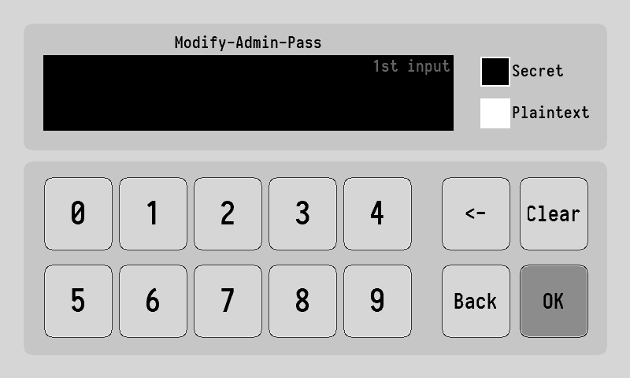

System
There is para reset, date /time, registration, backup/recovery, data import/export in the system maintenance.

Para. reset
Click system to reset the corresponding parameter value. The parameter value will be restored to the factory setting. Please operate with caution.
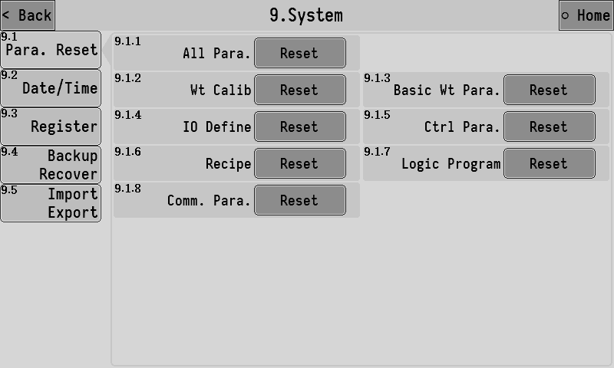

Date/Time
The time and date of the controller can be modified.
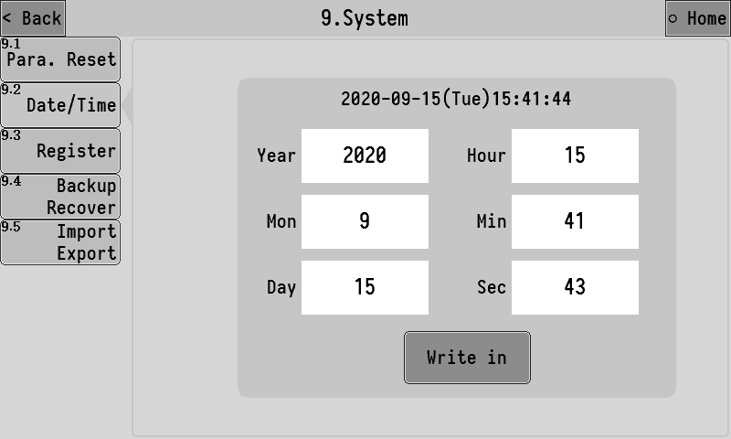

register
Product usage registration Settings.

backup recover
The parameter values currently set by the controller can be backed up to memory in the local machine and can be restored when needed.
On the left side, you can select the parameter items to be backed up. On the right side, you can see if there are any files to be backed up on the current machine, And the date of the current backup file on the machine is displayed, it can delete files that are currently backed up.
To prevent misoperation, when entering the parameter backup and restore interface, by default backup button and delete backup button is in the disabled state, required special operations to enable backup and delete backup, the operation method is to click position three times as shown in the figure below，then click positionthree times, and then click position three times to turn on the backup and delete backup functions.
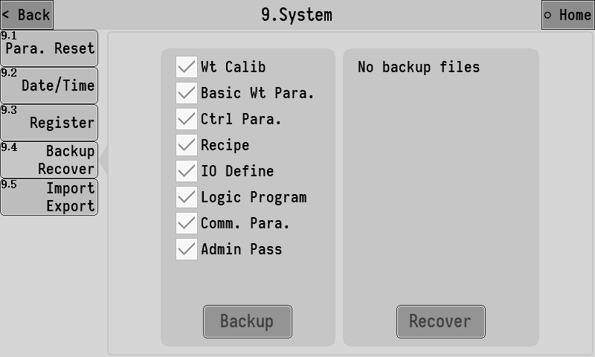

Import and export
The controller can export the parameters currently set to the usb flash disk, and the export file is in CSV format.
Data export operation:
Select the parameter items to be exported on the left side of the interface, after inserting the USB flash disk, click USB export to export the selected items to the USB flash disk.
USB export can export the select item to USB flash disk.
Input import operation:
Insert a USB flash drive with data files, and the list on the right side of the interface will show the data files existing in the current USB flash drive, select the data file to be imported and click USB import is ok.
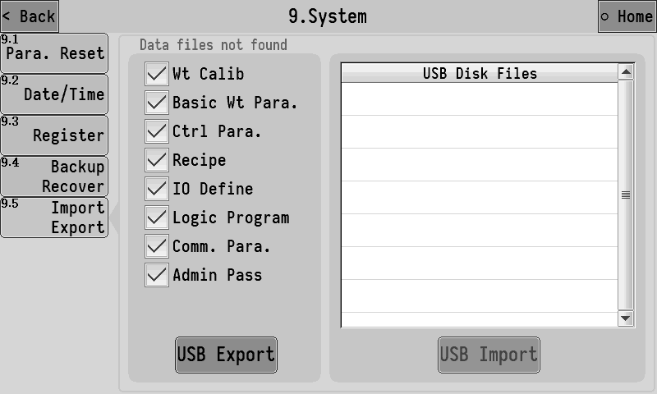

Logic program
The controller supports 6 logical programming functions,when the existing functions of the controller cannot meet the control requirements of the device, the logical programming function can be tried,define auxiliary logical output signals outside the controller running process to control device action.
The interface of logical programming setting is as follows:
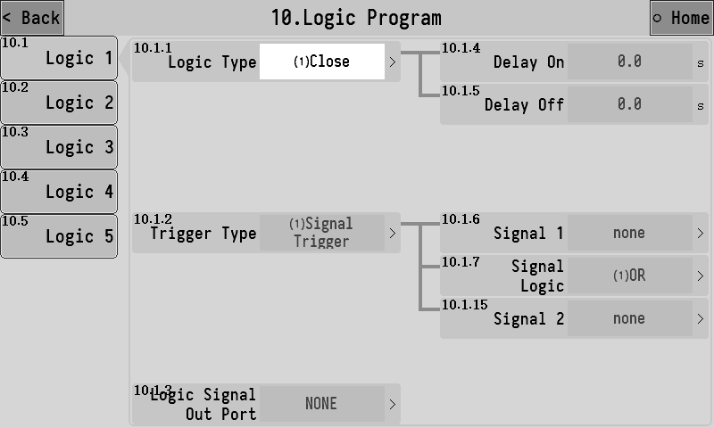
The following is an example of logical programming 1 to explain the role of each parameter:
10.1.1 | Logic type | Select the type of logical programming.  1.[close]：Turn off the logical output function.  2.[Delay on]  3.[Delay off]  4.[ Delay on and delay off]  5.[ effective - ineffective jump edge trigger]  6.[ fail-effective jump edge trigger]  7.[ Since the lock]  See the corresponding function description for details：错误!未找到引用源。
10.1.2 | Trigger time | 1.[ Signal trigger]：This logical output is triggered by a signal.  2.[ Condition trigger]：This logical output is triggered by reaching a certain condition.
10.1.3 | Logic signal out port | Select the logical output signal to define to an OUT outlet.
10.1.4 | Delay on time | The time that the logical output signal is delayed on.
10.1.5 | Delay off time | The time that the logical output signal is delayed and disconnected.
10.1.6 | Trigger signal 1 setting | Select the signal 1 used to trigger the logical output.
10.1.7 | Signal logic | Select the logical relationship between trigger signal 1 and trigger signal 2 used to trigger the logical output.  1.[or]：Trigger signal 1 and trigger signal 2 any valid signal can trigger the logical output.  2.[with]：Trigger signal 1 and trigger signal 2 need to be both valid to trigger the logical output.  3.[xor]：Trigger signal 1 and trigger signal 2 cannot trigger the logical output at the same time.
10.1.8 | Output effective time | 【10.1.1 Logic type】Set to item 5/6 to set this parameter. The effective time of the output after the trigger of the logic signal, and the time to the end of the logical output.When this time is set to 0, the logical output signal will be terminated only by the reset signal.
10.1.9 | Reset signal setting | 【10.1.1 Logic type】Set to item 5/6 to set this parameter. After the logical output is effective, the reset signal can reset the logical output, making the logical output signal invalid and ending the logical output process.
10.1.10 | Reset signal logic | 1.[ Effective reset]：Reset logic output when reset signal is valid.  2.[ Invalid reset]： When the bit signal is invalid, reset the logical output.
10.1.11 | Trigger setting | Select the condition that triggers the logical output.  1.[ The weight is greater than the set value]  2.[ The weight is less than the set value]  3.[ The weight is within the range]  4.[ The weight is outside the range]
10.1.12 | set point 1 | Used to set the weight value of the trigger condition.
10.1.13 | set point 2
10.1.14 | Weight stability condition | 1.[ opened]：The weight meets the set trigger condition, and the logic output cannot be triggered until the weight is stable.  2.[ closed]：The weight meets the set trigger condition and can trigger the logic output without stability.
10.1.15 | Trigger signal 2 setting | Choose to triggers the signal 2 logical output.

Logical output sequence diagram

Example
Code function：After the pocket output signal is valid, it will be delayed for 1s, and then output OUT12 will be continued for 2s, which is used to control the coding machine to print the code on the bag after the bag is filled.

The setting is as follows:
【Logic type】：Invalid - valid jump along trigger
【Delay time】：1s
【Output effective time】：2s
【Trigger type】：Signal trigger
【Trigger setting】：Clamp
【Logical signal output port】：OUT12

Through the cooperation of different trigger signals, trigger conditions and 5 groups of logical programming signals, the output of very flexible logic signals can be combined.
For example, the following logic should be implemented: real-time detection of weight higher than 100kg, namely output OUT10 for alarm instruction. When the alarm is effective, it will delay 2s and output OUT11 lasts 3s to control the discharging mechanism to discharge the materials.
The setting is as follows:
Logic programming 1：The test weight above 100kg is output OUT10。
【Logic type】：Delay on
【Delay time】：0s
【Trigger type】：Condition triggered
【Trigger setting】：The weight is greater than the set value
【set point 1】：100kg
【Logical signal output port】：OUT10
Logic programming 2：When OUT10 is effective, it will delay 2s and output OUT11 will last 3s.
【Logic type】：Invalid - valid jump along trigger
【Delay time】：2s
【Output effective time】：3s
【Trigger type】：Signal trigger
【Trigger setting】：Logical output 1
【Logical signal output port】：OUT11

4. Process instruction

Valve Scale packaging process
The basic packaging process of Valve Scale will be explained in combination with the above figure:

- Start running.
- Wait for the bag clamping
- After the the bracket rise, delay before starting feeding, and stable peeling after the end of the delay (for the net package, no peeling for the gross package).
- After successfully removing the skin, open the large feed ,when the weight value≥target value -leading quantity of fast feeding, close fast feeding, open moderate feeding.
- When the weight value≥target value-leading quantity of moderate feeding, close moderate feeding and open slow feeding.
- When the weight value≥target value-slow feeding drop in level number ,close slow feeding and end feeding ,start fixed value and hold time.
- After the maintenance time of the fixed value is over, the weight of feeding shall be recorded, and it shall be judged whether to carry out overbalance detection and drop correction according to the setting of control parameters
- Push bag ,unload bag。
- Complete the first packaging process and return to step 1 to start a new packaging process.

Note：
①over/und detection and drop correction：See Section 3.3.3 for detailed control parameter Settings.
②Push bag ,unload bag：Push bag ,unload bag pracess according to the setting of 【3.4.7 unloading control mode】, there are different timing sequence, which are as follows:

AMC501-F-920B1
BKG:2020.09.15

